Introduction to Low-Code Development & FlutterFlow Overview
Low-code development is changing the way applications are built. It allows developers and non-developers to create software with minimal hand-coding by using visual interfaces, drag-and-drop components, and pre-built logic blocks.
This approach significantly reduces development time while improving productivity and accessibility for people with limited programming experience.
In this guide, we will cover:
● What low-code development is
● Why it is becoming popular
● Overview of FlutterFlow
● How FlutterFlow fits into the low-code ecosystem
● Key benefits and limitations
1. What is Low-Code Development?
Low-code development is a software development approach where applications are built using visual interfaces instead of writing extensive code manually.
Instead of writing full backend and frontend logic from scratch, developers use:
● Drag-and-drop UI builders
● Pre-built components
● Visual workflows
● Built-in integrations
Key Idea
Low-code platforms reduce traditional coding effort while still allowing customization when needed.
Traditional Development vs Low-Code
Traditional Development | Low-Code  Development
Full manual coding | Visual development
Longer development time | Faster development
Requires strong coding skills | Beginner-friendly
Harder prototyping | Rapid prototyping

2. Why Low-Code Development is Becoming Popular
Low-code platforms are widely adopted because they solve real-world development challenges.
Main Reasons
● Faster time to market
● Lower development cost
● Easier prototyping and iteration
● Reduced dependency on large engineering teams
● Accessibility for non-developers
Use Cases
● Startup MVP development
● Internal business tools
● Mobile and web applications
● Admin dashboards
● Workflow automation systems
3. Introduction to FlutterFlow
FlutterFlow is a visual development platform built on top of Flutter that allows users to build mobile and web applications without writing full code.
It provides a drag-and-drop interface where developers can design UI, connect backend services, and deploy apps quickly.
Key Features of FlutterFlow
● Visual UI builder (drag-and-drop)
● Firebase integration
● API integration support
● Pre-built widgets
● State management tools
● Built-in authentication flows
● One-click deployment
How FlutterFlow Works
FlutterFlow converts visual designs into Flutter code automatically.
Design UI visually
↓
Configure logic and data
↓
Generate Flutter code
↓
Deploy app to mobile or web
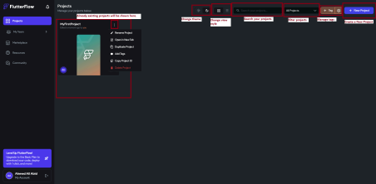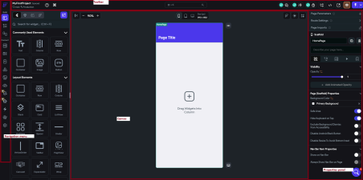
4. Why FlutterFlow is Popular in Low-Code Development
FlutterFlow is widely used because it combines:
● Visual development speed
● Flutter’s performance and flexibility
● Backend integrations like Firebase
● Exportable production-ready code
Key Advantages
● Fast app development without deep coding
● Clean Flutter code generation
● Works for both mobile and web apps
● Supports backend integrations (Firebase, APIs)
● Great for MVPs and startups
Limitations
● Complex custom logic may still require code
● Platform dependency for advanced features
● Learning curve for advanced workflows
● Some limitations in highly custom UI/UX designs
5. Where FlutterFlow Fits in the Low-Code Ecosystem
FlutterFlow sits between no-code and traditional development. Development Spectrum
● No-Code: Bubble, Glide
● Low-Code: FlutterFlow
● Traditional Code: Flutter (pure code), React Native
FlutterFlow gives a balance of:
● Speed of no-code tools
● Flexibility of real development frameworks
6. Typical FlutterFlow Architecture
FlutterFlow UI Builder
↓
Flutter Framework
↓
Backend Services (Firebase / APIs)
↓
Database + Authentication + Logic
Conclusion
Low-code development is reshaping modern software development by making it faster, more accessible, and more efficient.
FlutterFlow stands out as one of the most powerful low-code platforms because it combines visual development with real Flutter code generation.
Final takeaway:
FlutterFlow enables developers to build production-ready mobile and web applications faster while still maintaining flexibility through integrations and custom logic when needed.

